Assignment 01

Starting Client Side:
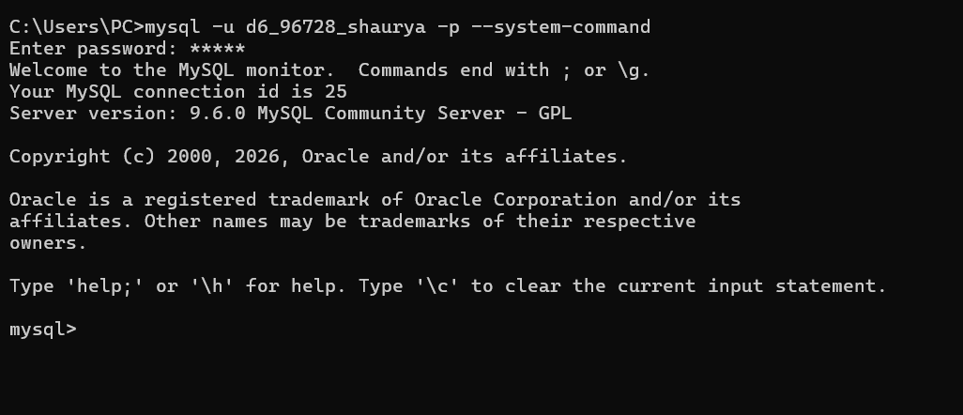

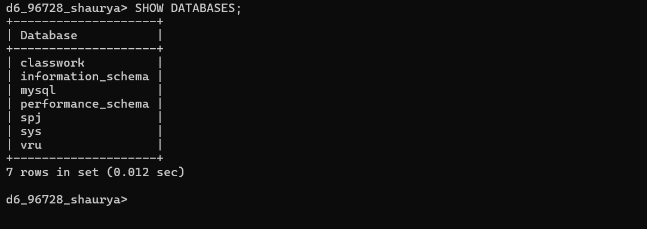

DATABASE Changed:
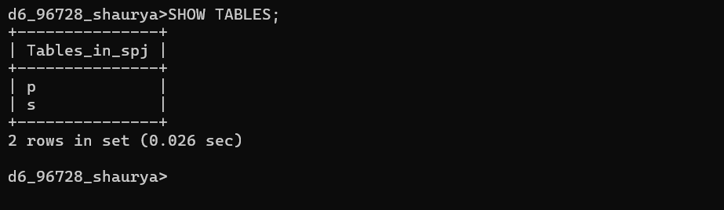

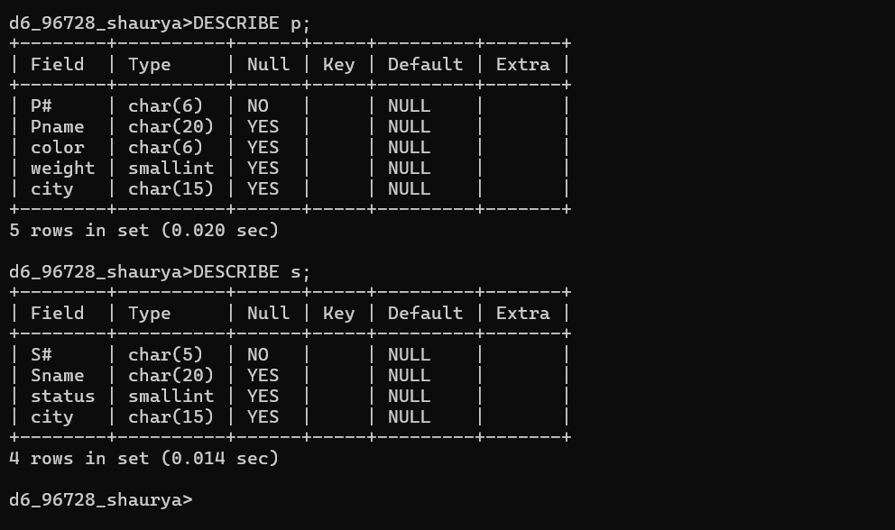

Creating and Populating J:
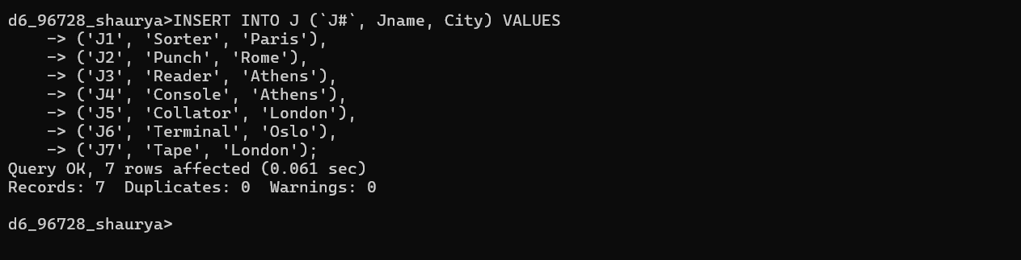

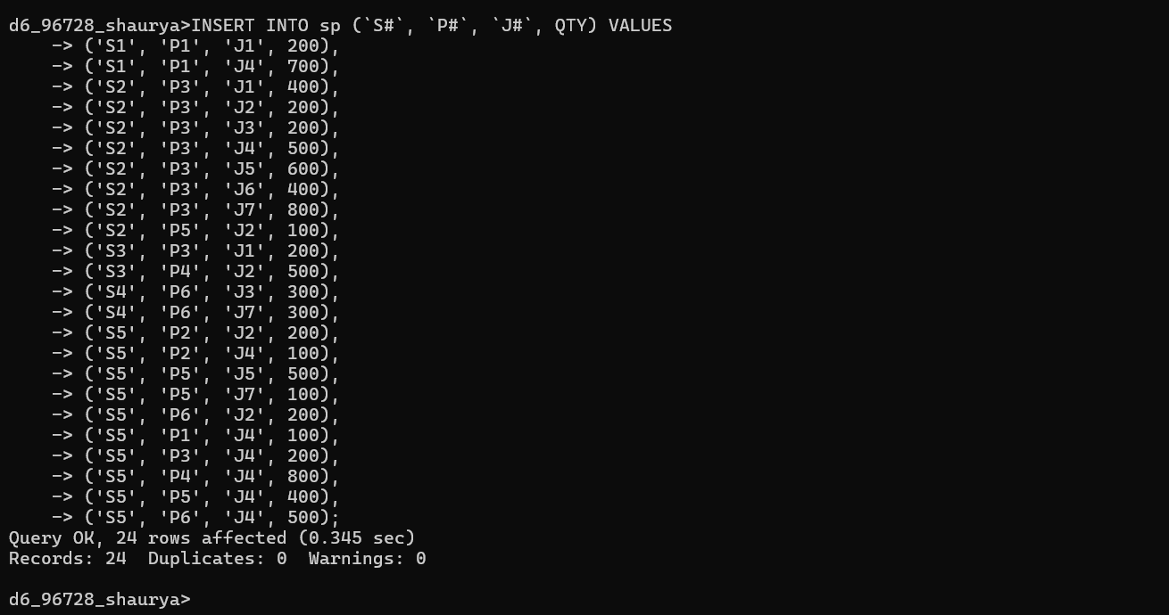

Importing HR database:

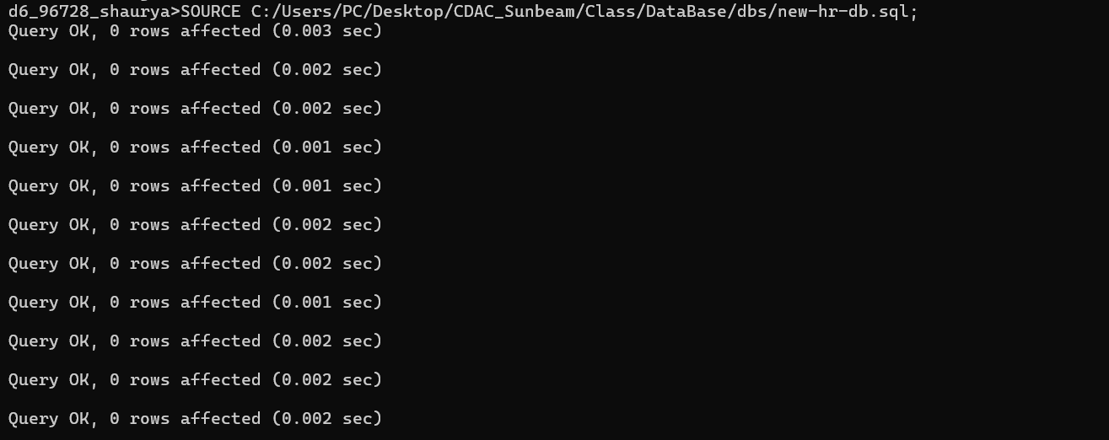

Importing Sales database:
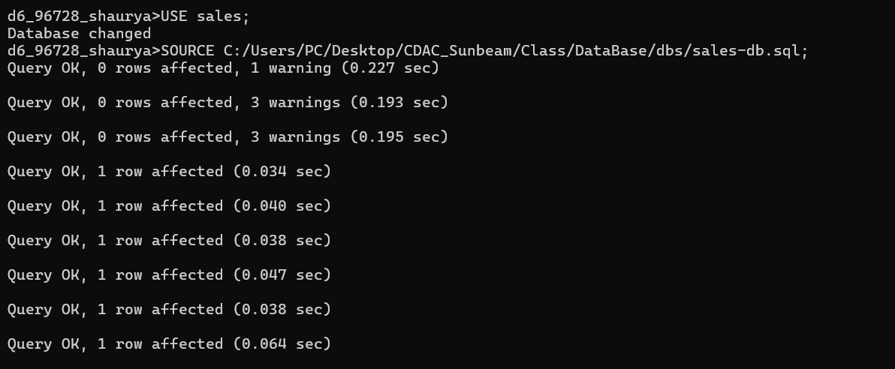

Viewing HR Tables

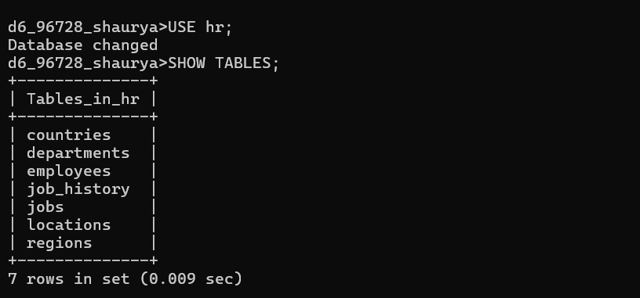
Table: Employee
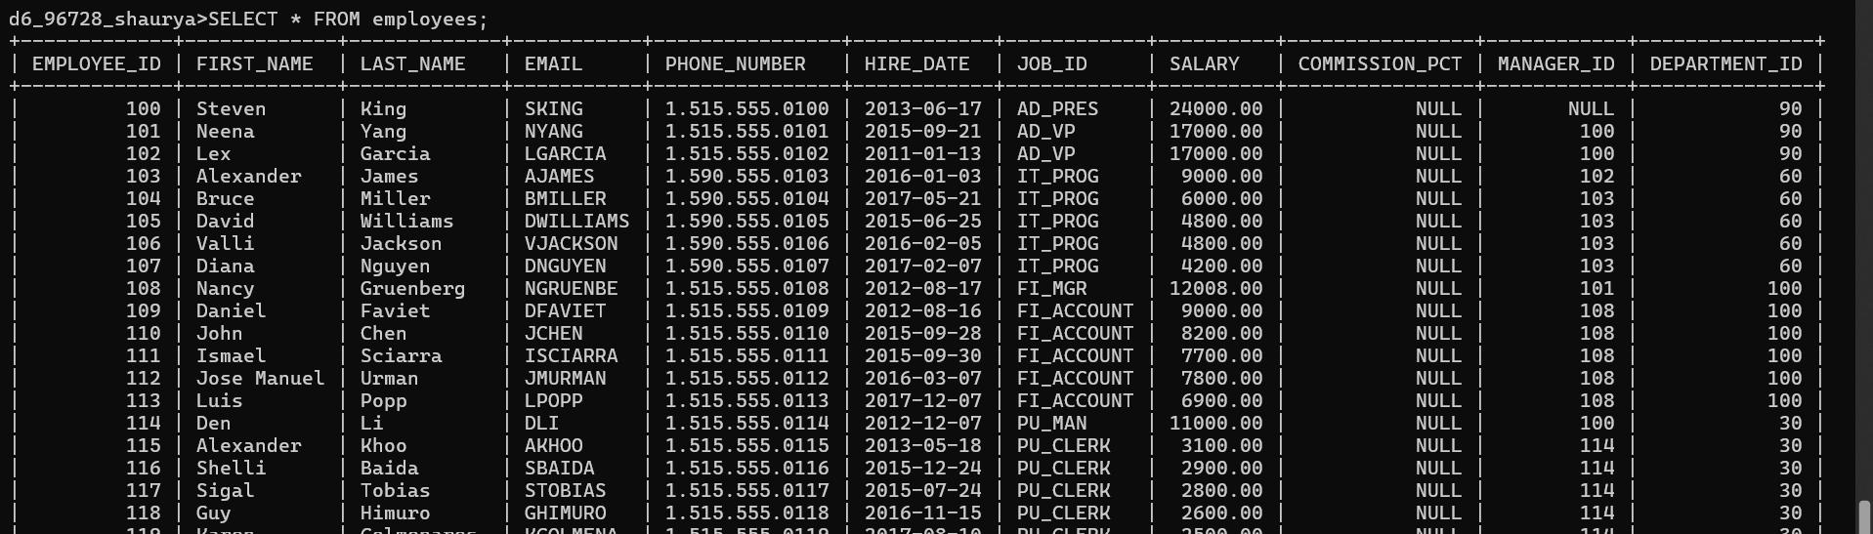

Viewing HR Tables:
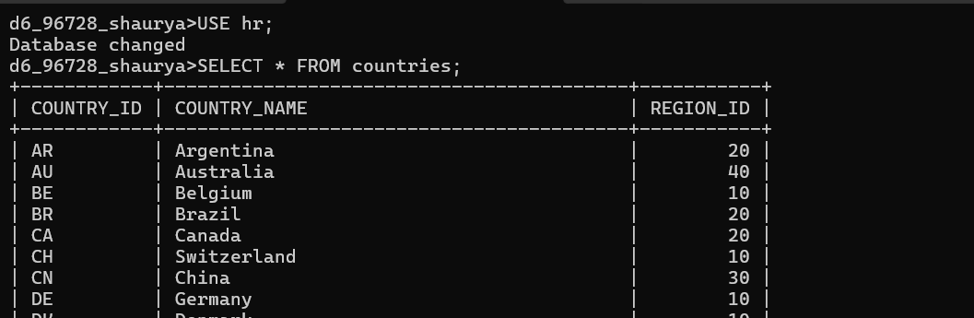

TABLE: departments

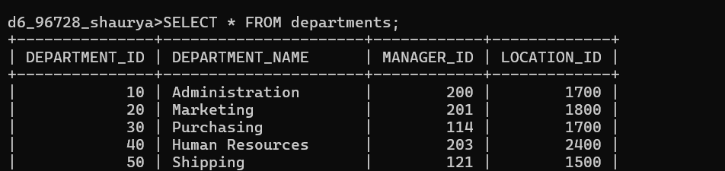

TABLE : employees
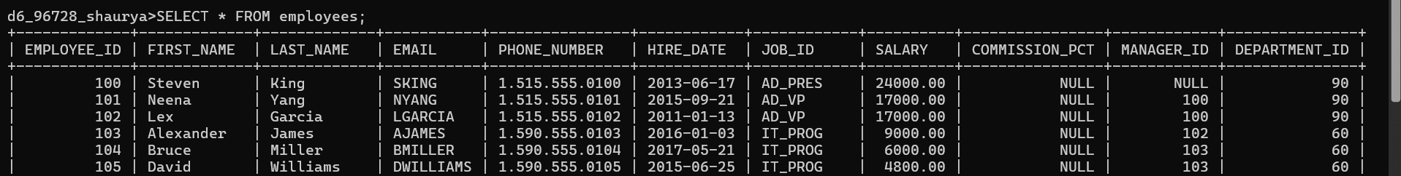

TABLE: job_history
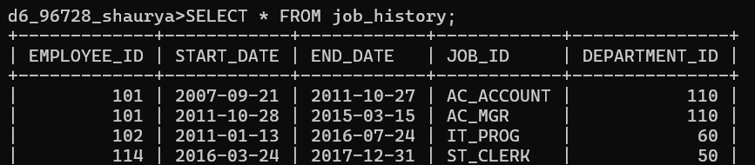

TABLE: jobs
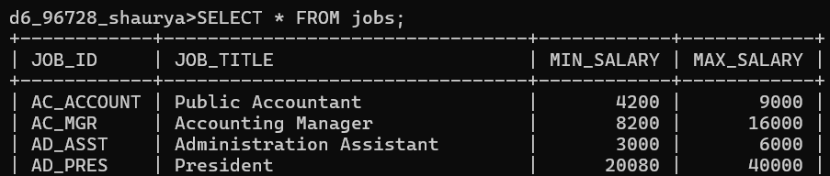

TABLE: locations
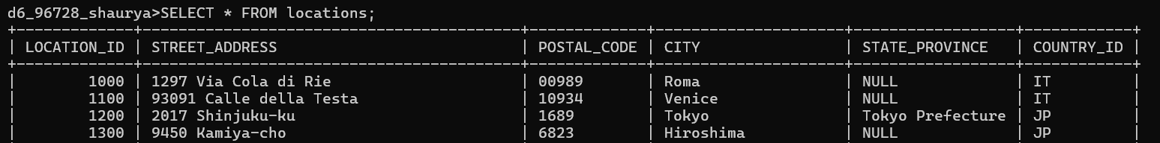

TABLE: regions

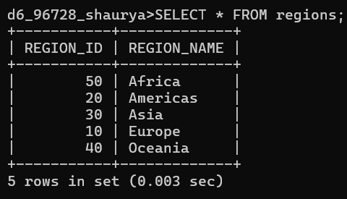
Viewing sales Tables:
TABLE: customers
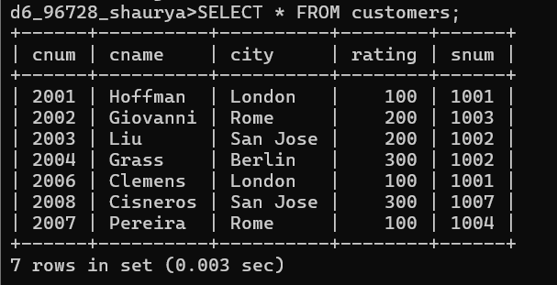

TABLE: orders

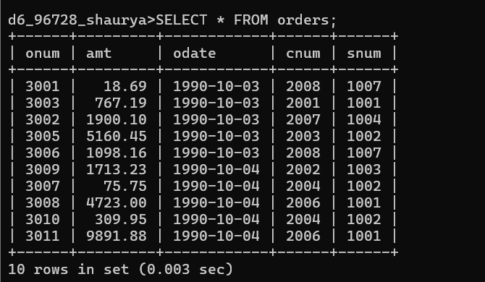

TABLE: salespeople
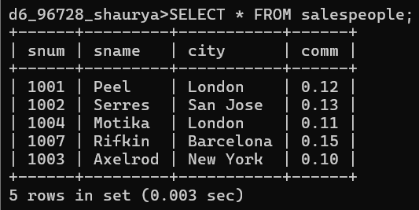

Observations:
- How many orders data is present in the database?
There are 10 orders present in the orders table.
- How many customers are present in the database?
There are 7 customers present in the customers table.
- How many salespeople are present in the database?
There are 5 salespeople present in the salespeople table.
- On which date order with highest amount is placed?
The highest amount order ($9891.88) was placed on 1990-10-04.
- For which order salesman got maximum commission?
The maximum commission was earned for Order 3011 (Commission: 1187.0256).
- Which salesmen are handling more than two customers?
None. According to the data, no single salesman is currently handling more than two customers (all handle 1 or 2).
- Which city have single customer?
Berlin is the only city with exactly one customer.
- Which city has multiple salespeople?
London has multiple salespeople.
- What is name of customer and salesman of the maximum amount order?
The customer is Clemens and the salesman is Peel for the order amounting to $9891.88.
- Study relationship between the tables in sales database.
Primary Keys: snum (Salespeople), cnum (Customers), and onum (Orders) uniquely identify rows in their respective tables.
Foreign Keys: The orders table is the "child" to both customers and salespeople, meaning it depends on them existing first.

